## Installing Agent Service

### To install the Windows Service using Visual Studio

1. Start Visual Studio as Administrator (right click on the shortcut and choose "run as administrator")
2. Re-Build the project (Build->Rebuild Solution)
3. To install the Windows service, right-click the setup project ("ServiceAgent Setup") in the Solution Explorer and select Install (note you can uninstall the same way)
4. A Wizard will appear to walk you through the installation. Use the default folder and choose "Everyone" for Install ServiceAgentSetup for (see below).

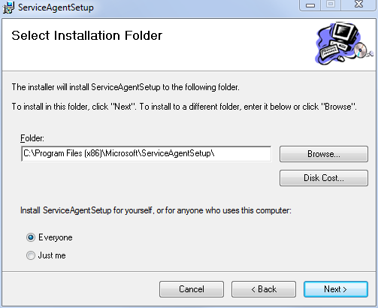

### To install the Windows Service using the .msi file

1. Go to C:\Palette\ServiceAgentSetup\Debug
2. Right click on ServiceAgentSetup.msi and choose "Install" (note you can uninstall the same way)
3. A Wizard will appear to walk you through the installation. Use the default folder and choose "Everyone" for Install ServiceAgentSetup for (see above).

### To start and stop your service

1. Open the Services Control Manager by doing the following:
2. Open the Windows Control Panel
3. Click on “System and Security”
4. Click on “Administrative Tools”
5. Double click on the “Services” icon
6. Look for a Service with the name “ServiceAgent”. It should have a “Manual” startup type
7. Right click on the Service and click “Properties”. On the “Log On” tab, check “Allow Service to interact with desktop” (see below)
8. Right click the service and select “start”
9. To stop the service, right click and select “stop”

### 

### To uninstall the Windows Service

1. Right click on ServiceAgentSetup.msi and choose "Uninstall" (you can do this in Visual Studio also)
2. A Wizard will appear to walk you through the uninstallation.
3. Check the Services Control Manager to see if the Service is still visible. If it is still running, right click on it and choose “Stop”. Then open a Command Shell and type “sc delete agent”. The service should be removed but if it is still visible a reboot may be required.

For more information on how to create the service in Visual Studio see: <http://msdn.microsoft.com/en-us/library/aa984464(v=vs.71).aspx>